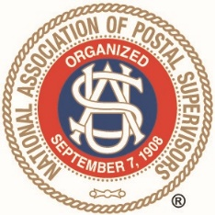
NATIONAL ASSOCIATION OF POSTAL SUPERVISORS
National Headquarters
1727 KING STREET, SUITE 400
ALEXANDRIA, VA 22314-2753
(703) 836-9660

To our members, as you may know, NAPS went through the process to trademark our 2 logos, the traditional historical logo and the sleek modern logo. Now that the process is finally complete, attached are guidance and instructions for use of the trademarked NAPS logos. Please review these, and share with other members in your areas … We will be posting this information on the NAPS website to provide these instructions to our members and vendors. Our intent is not to charge members for use of the trademarked logos, but to have control over who is using the logos, and for what purpose.
For vendors, we will review applications to use the logos, and similarly NAPS just seeks to know who is using the logo, and for what commercial purpose. Determinations on whether to charge for use of the logos for business purposes will be made on a case by case basis. For those vendors we have regularly done business with, and who contribute to our various NAPS functions, we will not necessarily charge to use the NAPS logos. Again, our main purpose for trademarking the logos was to control who is using them and for what purpose.
Applications to use the NAPS logos, for members and vendors, must be sent to NAPS HQ for review. Thank you.

Representing supervisors, managers and postmasters in the United States Postal Service

